- Introducing Windows Functions

Window functions perform aggregate operations on groups of rows, but they “produce a result FOR EACH ROW”

_________________________________
EMP_NO department salary
___________________________________________
8 sales 59000
12 sales 60000
20 customer service 56000
21 customer service 55000
___________________________________________

SELECT emp_no, department, salary,
AVG(salary) OVER(PARTITION BY department) AS dept_avg FROM emps;

‘Sales’ window
____________________________________________
| 8 sales 59000 |
| 12 sales 60000 |
_____________________________________________

‘Customer service’ window

_______________________________________
| 20 customer service 56000 |
| 21 customer service 55000 |
_________________________________________

WINDOW OUTPUT
___________________________________________
EMP_NO department salary dept_avg
________________________________________________________
20 customer service 56000 55500.0000
21 customer service 55000 55500.0000
8 sales 59000 59500.0000
12 sales 60000 59500.0000
_________________________________________________________

GROUP BY collapses each group of rows INTO a single result.
Call all sort of aggregate functions and reduce down these groups in to a single row.

_________________________________
EMP_NO department salary
___________________________________________
8 sales 59000
12 sales 60000
20 customer service 56000
21 customer service 55000
___________________________________________

SELECT department, AVG(salary) FROM emps GROUP BY department;

‘Sales’ group
_____________________________________________
| 8 sales 59000 |
| 12 sales 60000 |
_______________________________________________

‘Customer service’ group
_______________________________________________
| 20 customer service 56000 |
| 21 customer service 55000 |
_________________________________________________

GROUP BY OUTPUT
____________________________
Department AVG(salary)
____________________________

Sales 59500.0000
Customer service 55500.0000
____________________________

- USING OVER CLAUSE

The OVER() clause constructs a window. When it’s empty, the window will include all records.

CODE:

- CREATE TABLE employees (
- emp_no INT PRIMARY KEY AUTO_INCREMENT,
- department VARCHAR(20),
- salary INT
- );

- INSERT INTO employees (department, salary) VALUES
- ('engineering', 80000),
- ('engineering', 69000),
- ('engineering', 70000),
- ('engineering', 103000),
- ('engineering', 67000),
- ('engineering', 89000),
- ('engineering', 91000),
- ('sales', 59000),
- ('sales', 70000),
- ('sales', 159000),
- ('sales', 72000),
- ('sales', 60000),
- ('sales', 61000),
- ('sales', 61000),
- ('customer service', 38000),
- ('customer service', 45000),
- ('customer service', 61000),
- ('customer service', 40000),
- ('customer service', 31000),
- ('customer service', 56000),
- ('customer service', 55000);

- SELECT emp_no, department, salary, AVG(salary) OVER() FROM employees;

- SELECT
- emp_no,
- department,
- salary,
- MIN(salary) OVER(),
- MAX(salary) OVER()
- FROM employees;

- SELECT
- emp_no, department, salary, MIN(salary), MAX(salary)
- FROM
- employees;

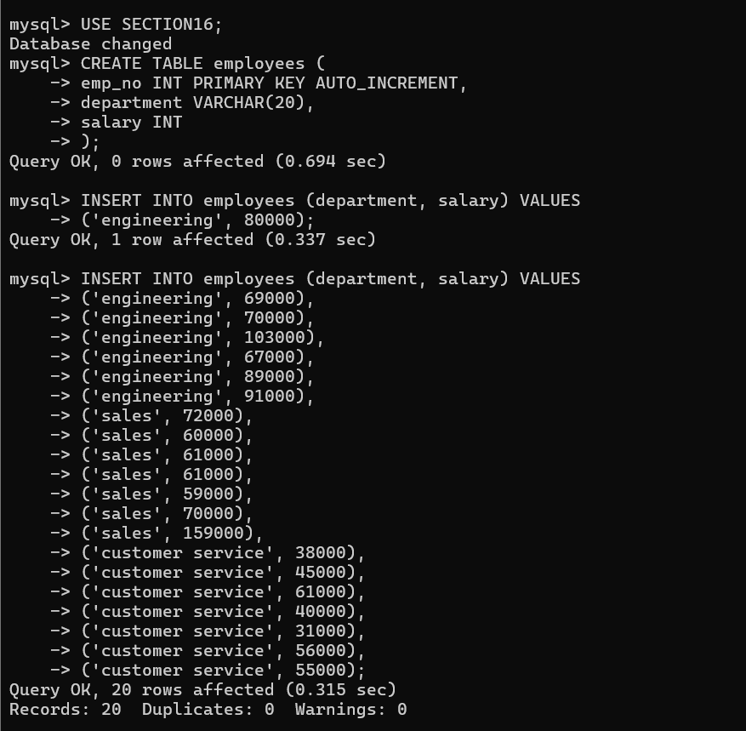

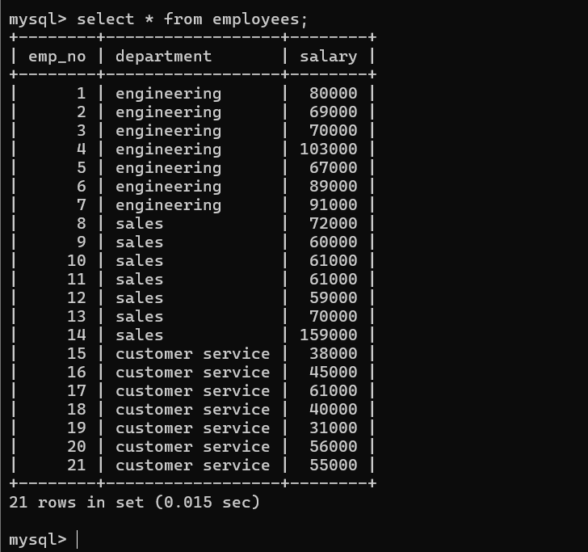

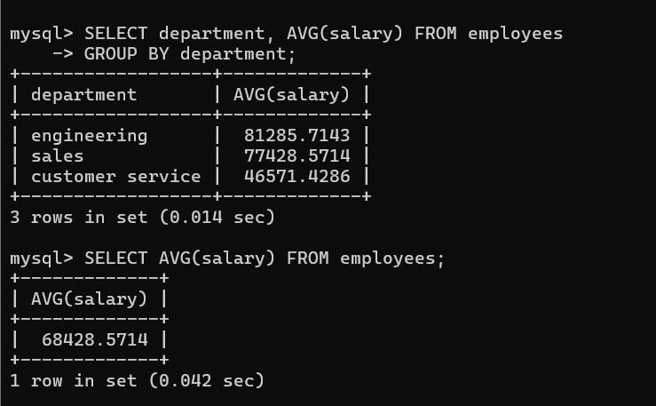

The first average salary is each department and the second average outcome salary is the whole department average salary.

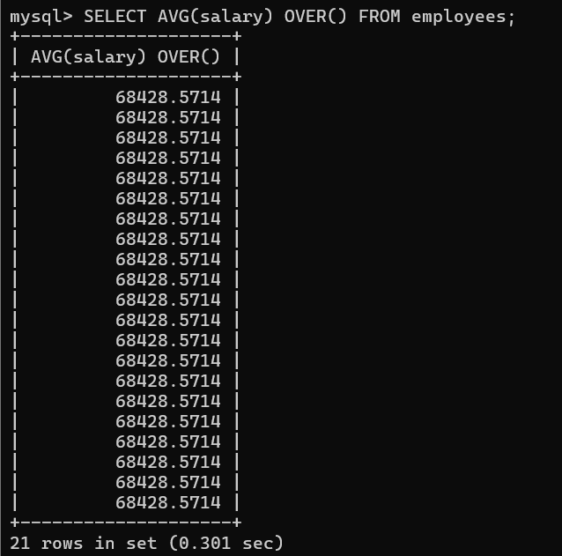

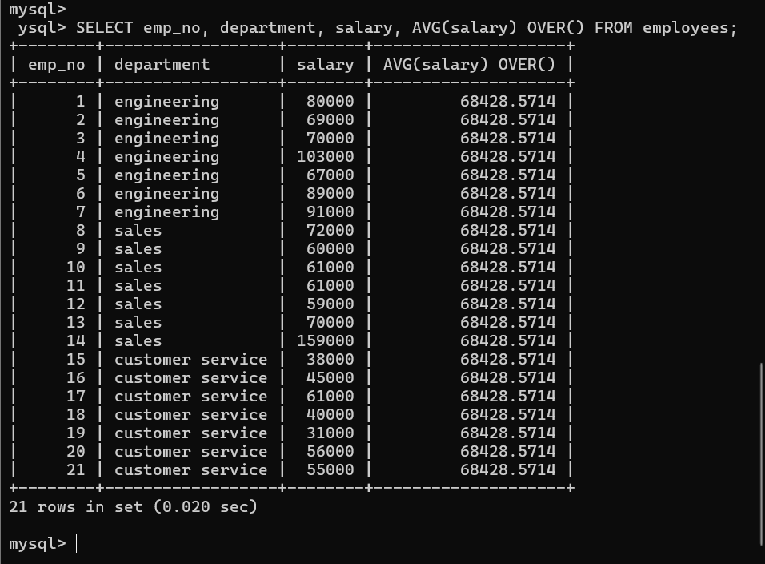

MIN AND MAX

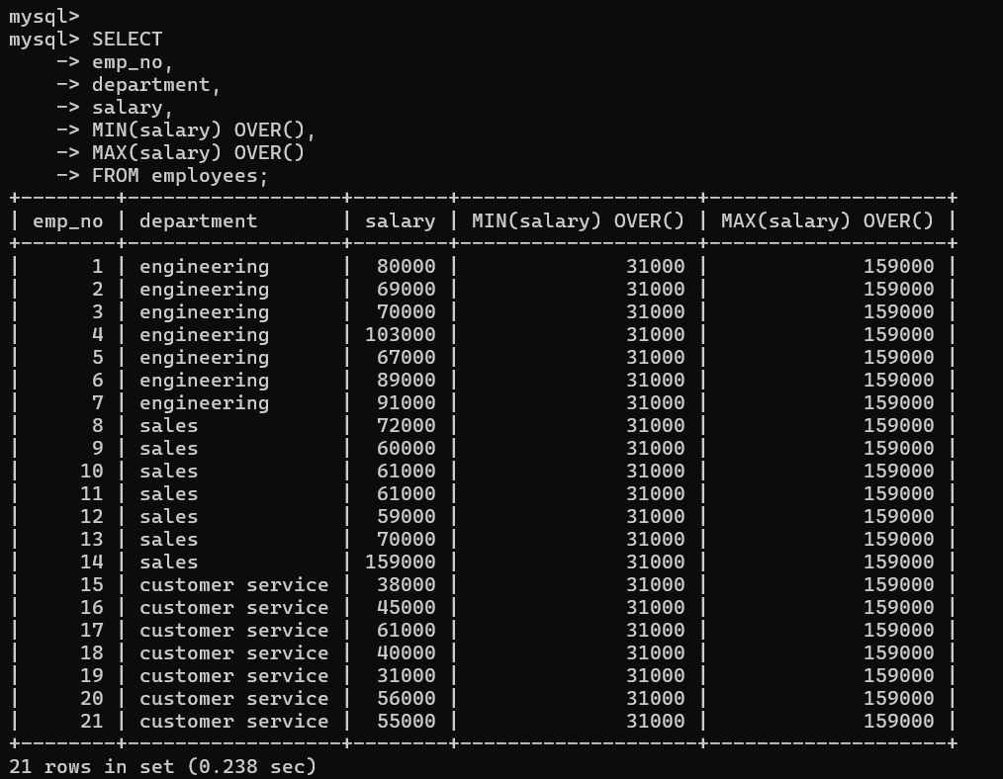

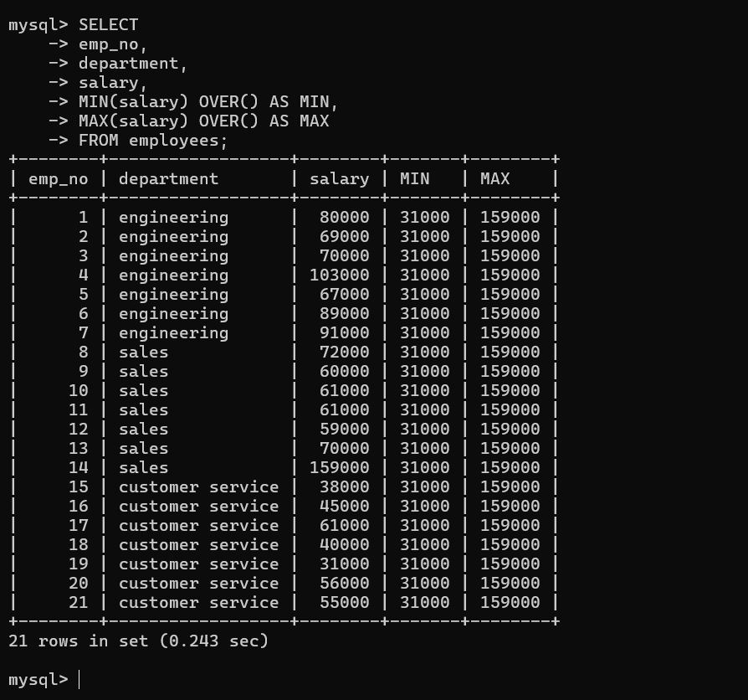

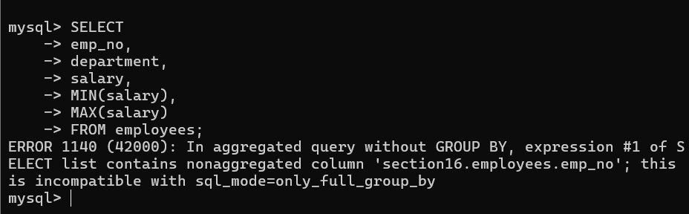
Trying to do a GROUP BY expression.
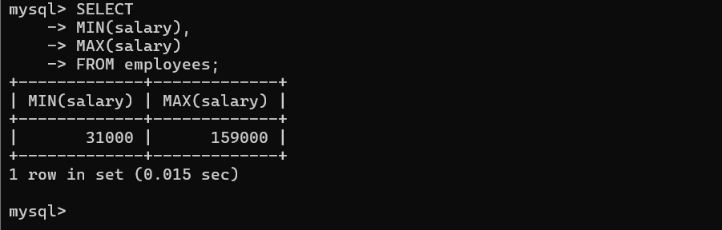

- PARTITION BY

Inside of the OVER(), use PARTITION BY to form rows into groups of row.

AVG(salary) OVER(PARTITION BY department)

CODE:
- SELECT
- emp_no,
- department,
- salary,
- AVG(salary) OVER(PARTITION BY department) AS dept_avg,
- AVG(salary) OVER() AS company_avg
- FROM employees;

- SELECT
- emp_no,
- department,
- salary,
- COUNT(*) OVER(PARTITION BY department) as dept_count
- FROM employees;

- SELECT
- emp_no,
- department,
- salary,
- SUM(salary) OVER(PARTITION BY department) AS dept_payroll,
- SUM(salary) OVER() AS total_payroll
- FROM employees;

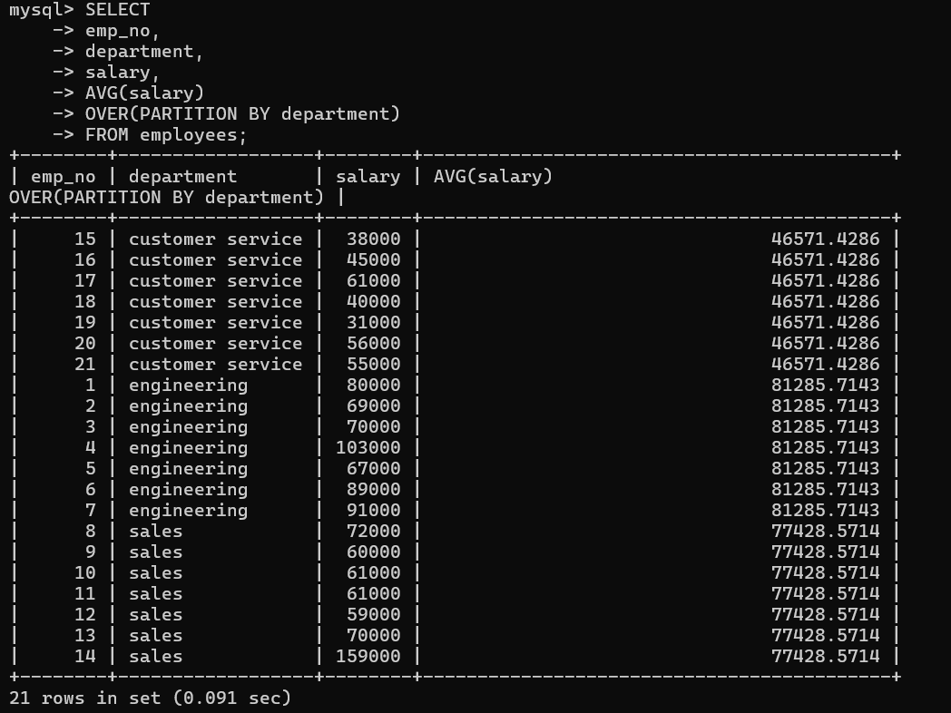

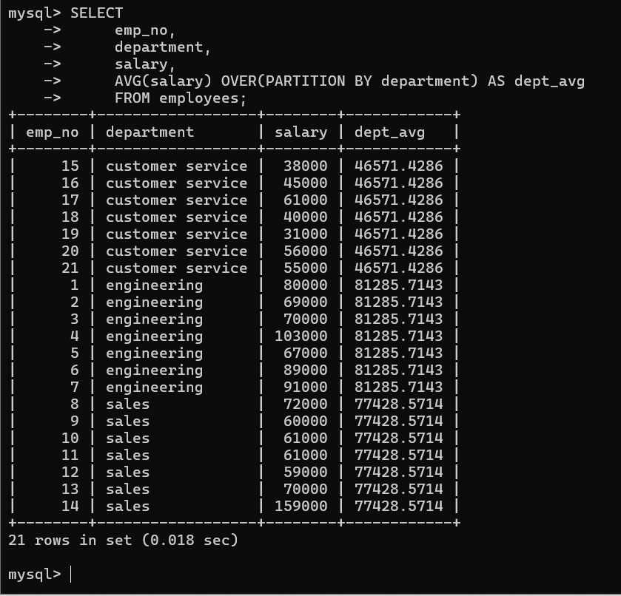

Each department's average salary.

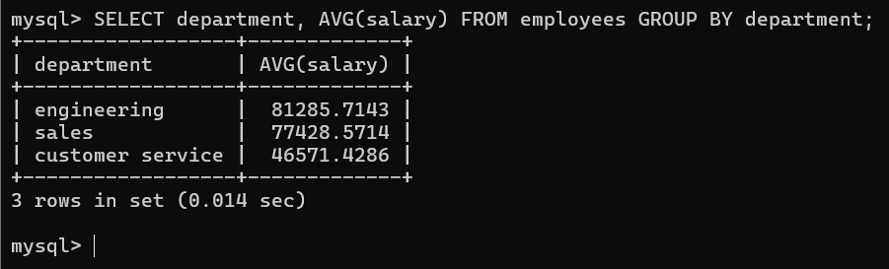

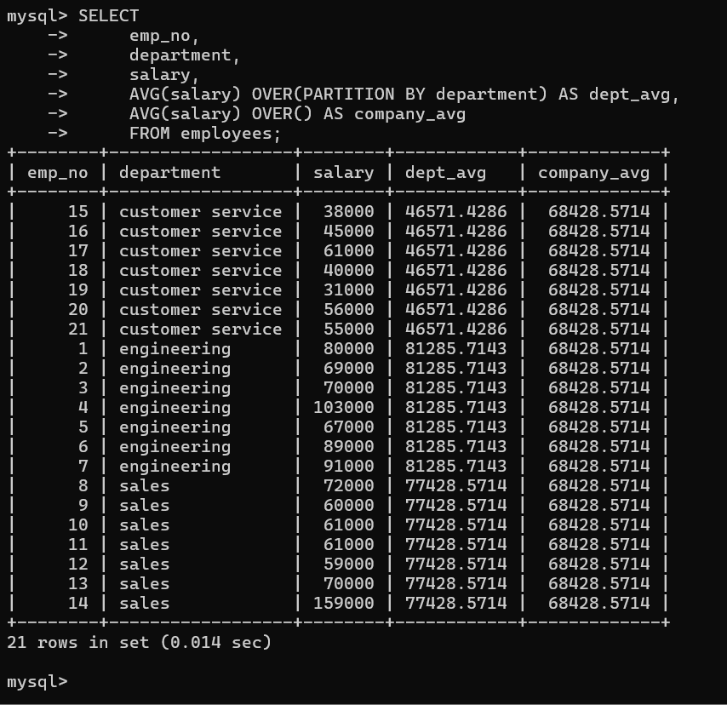
Each department's average salary is the dept_avg column and total average salary that is the company_avg column “WHOLE DEPARTMENT”.

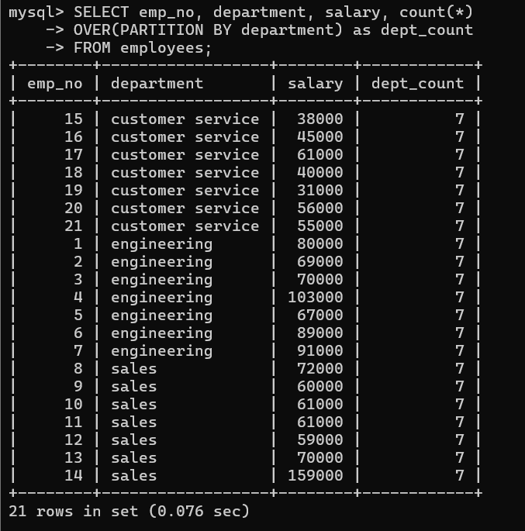

Each department counts.

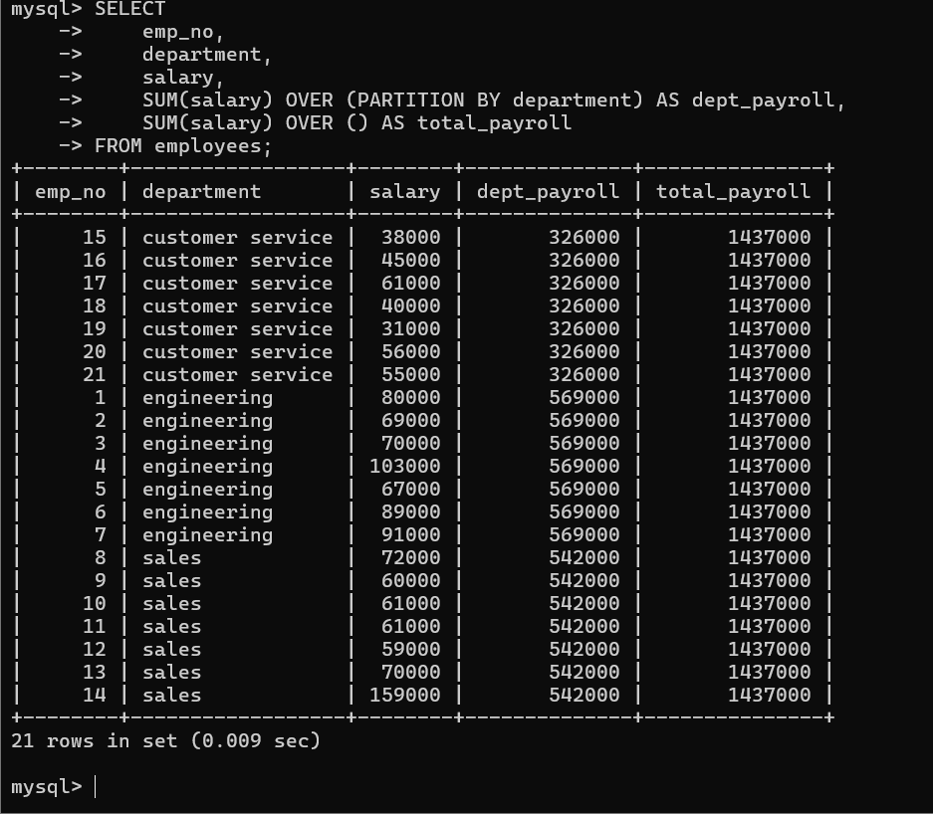

Department_roll is calculated that format is 38000+45000+61000+41000+31000+56000+55000 => “customer service 326000” that is similar to each department calculation, “engineering dept => 569000” “sales department => 542000” and total_payroll is calculated by depat_payroll each department salary -> 326000 + 569000 + 542000 => 1437000.

- ORDER BT WITH WINDOW

Use ORDER BY inside of the OVER() Clause to re-order rows within each window.

OVER(ORDER BY salary DESC);

CODE:

- SELECT
- emp_no,
- department,
- salary,
- SUM(salary) OVER(PARTITION BY department ORDER BY salary) AS rolling_dept_salary,
- SUM(salary) OVER(PARTITION BY department) AS total_dept_salary
- FROM employees;

- SELECT
- emp_no,
- department,
- salary,
- MIN(salary) OVER(PARTITION BY department ORDER BY salary DESC) as rolling_min
- FROM employees;

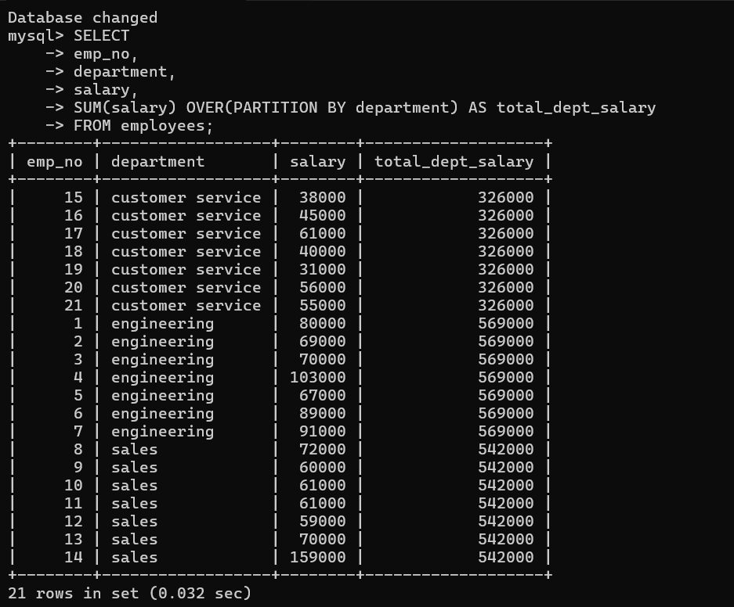

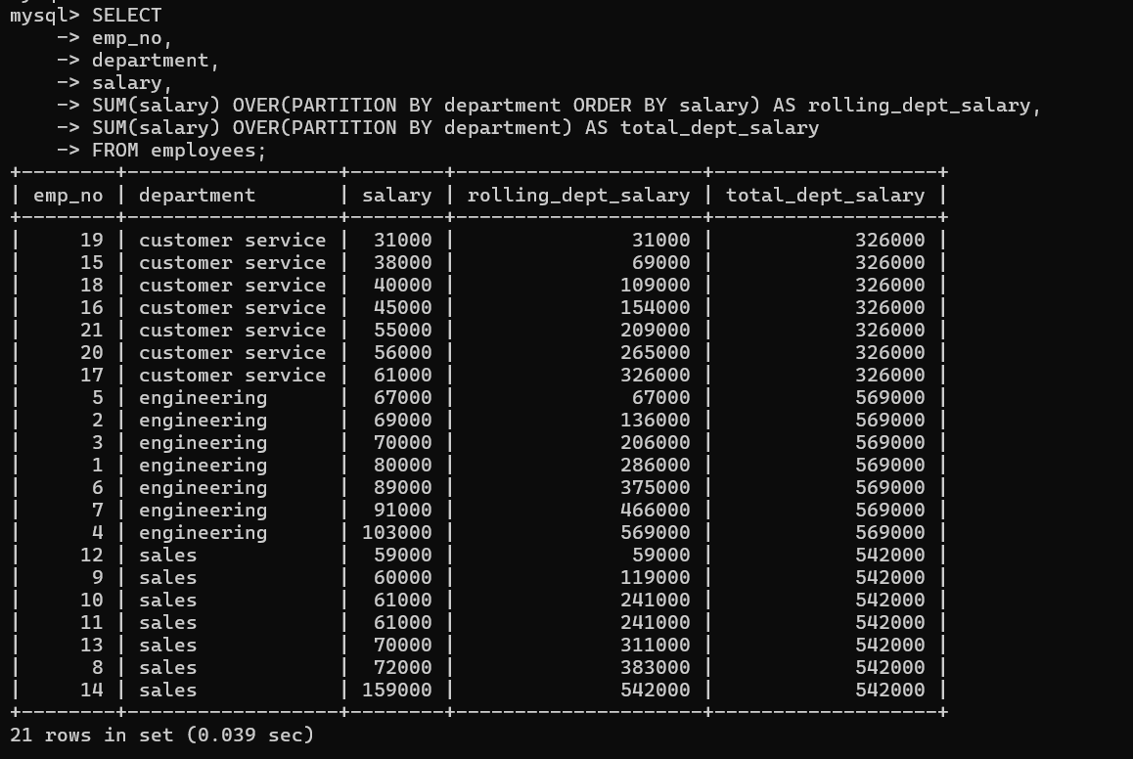

|->Rolling_dept_salary row calculated by add that method is 31000+38000=>69000+40000=>109000+45000=>154000+55000=>209000+56000=>265000+61000=>326000
Total_dept_salary row calculated that comes from the rolling_dept_salary each department.

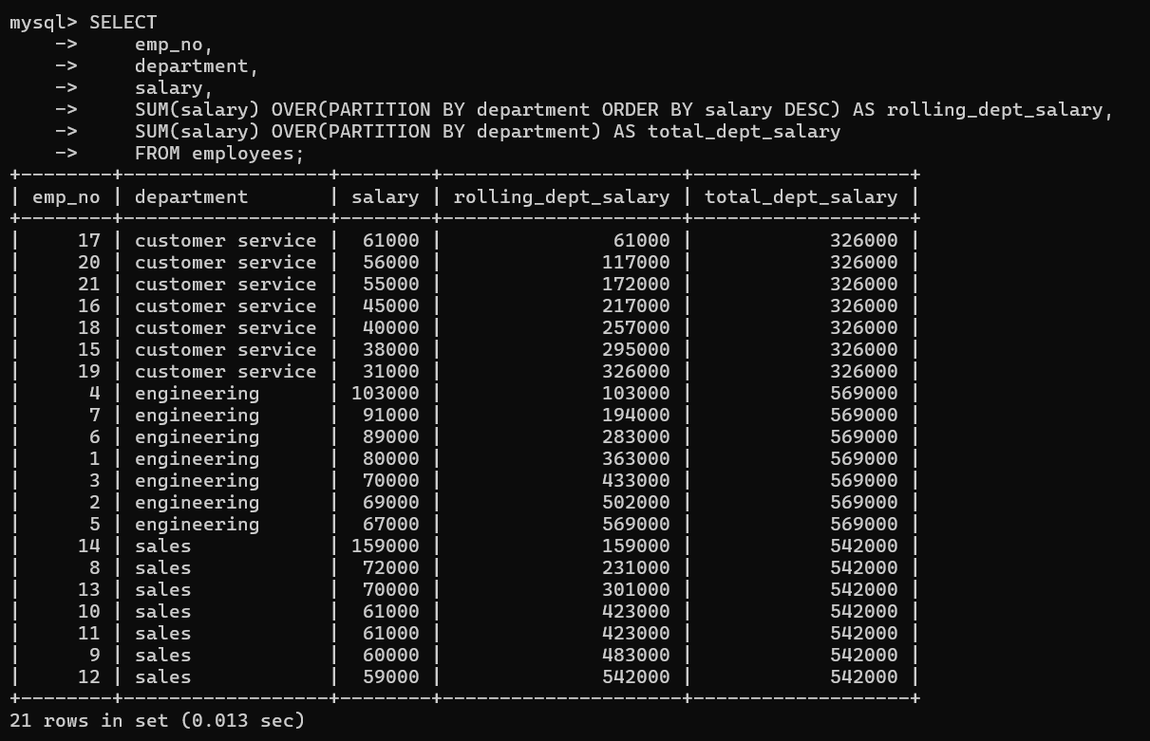

Rolling_dept_salary is calculated by desc order.

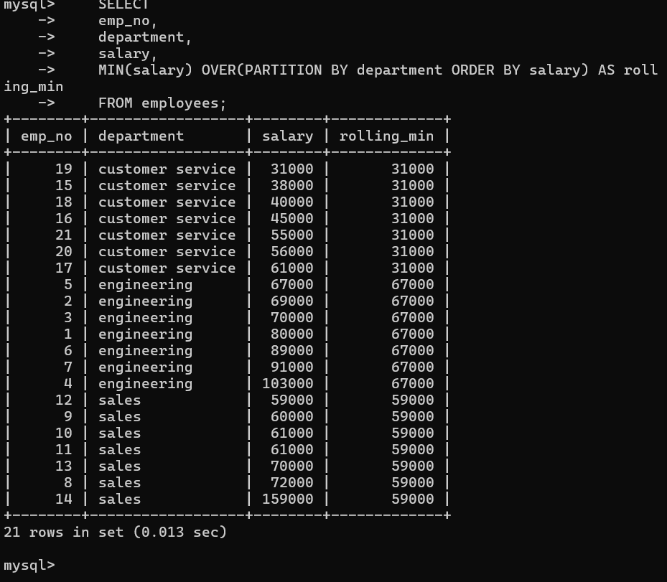

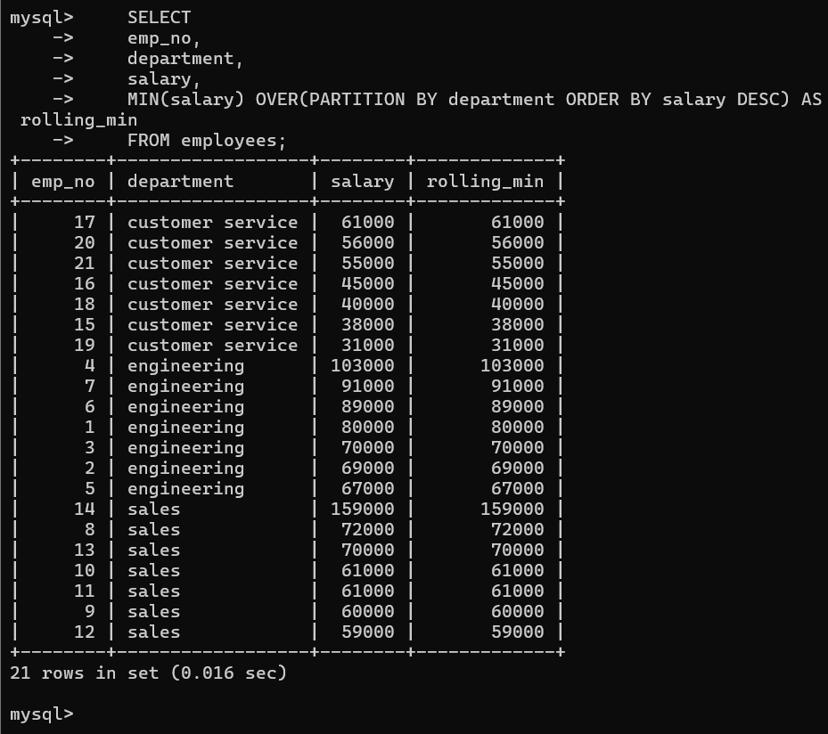

- Rank
Returns the rank of the current row within its partition, with gaps.

Rank is who has the highest salary or mark give the outcome as 1,2,3,..n
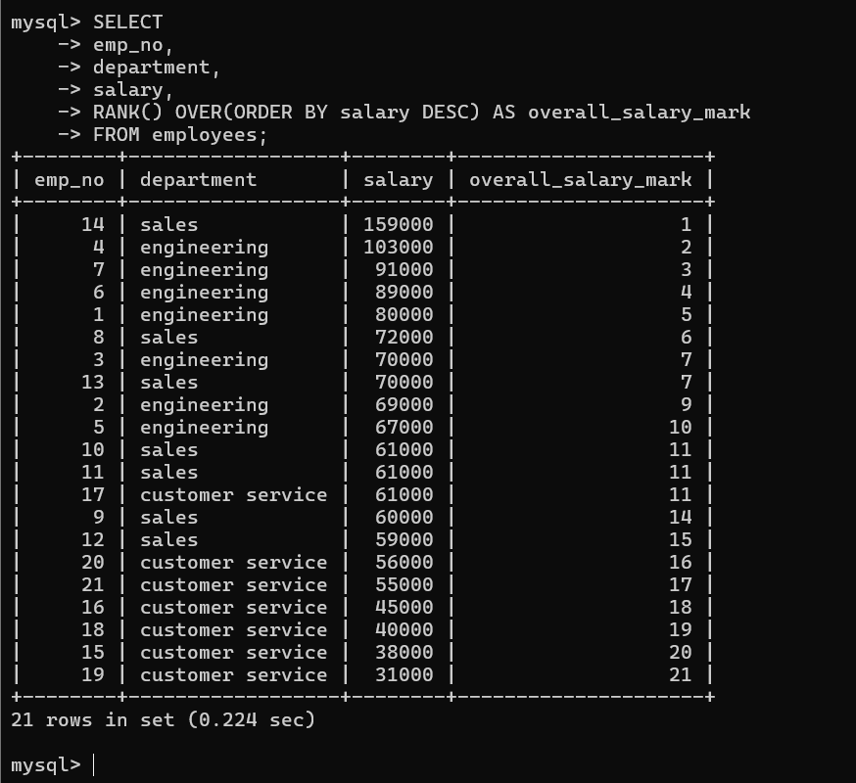

Skip the number following that. 2 sevens and then nine. 8 does not write 13. After 9 was assigned in the 2. It’s not the same as just counting the rows.

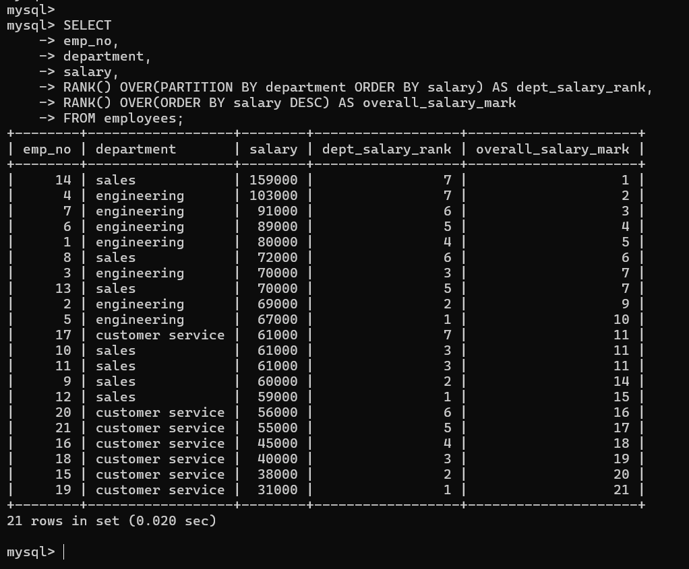

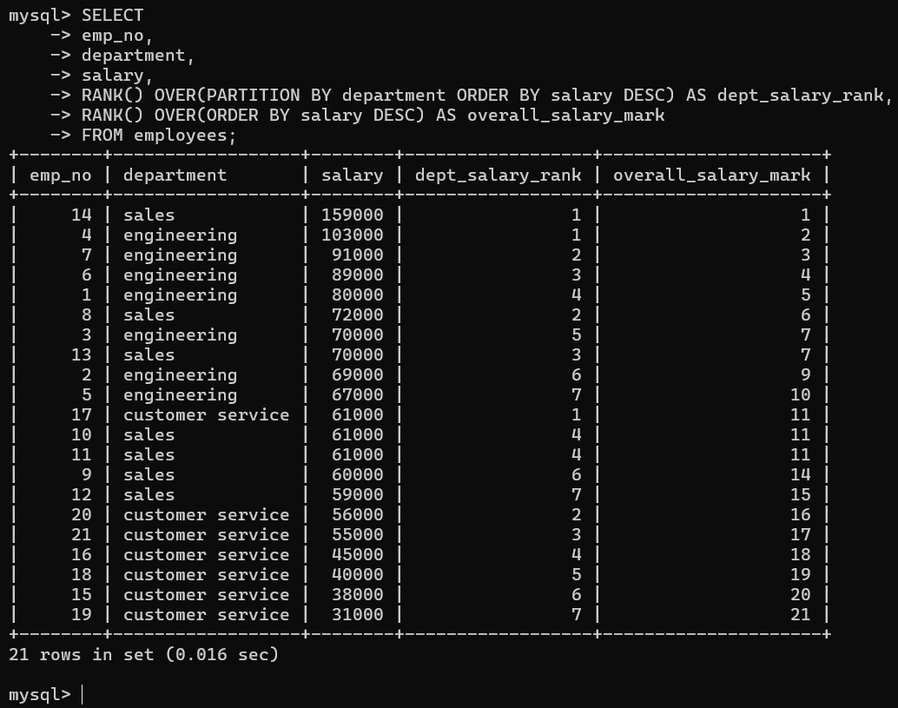

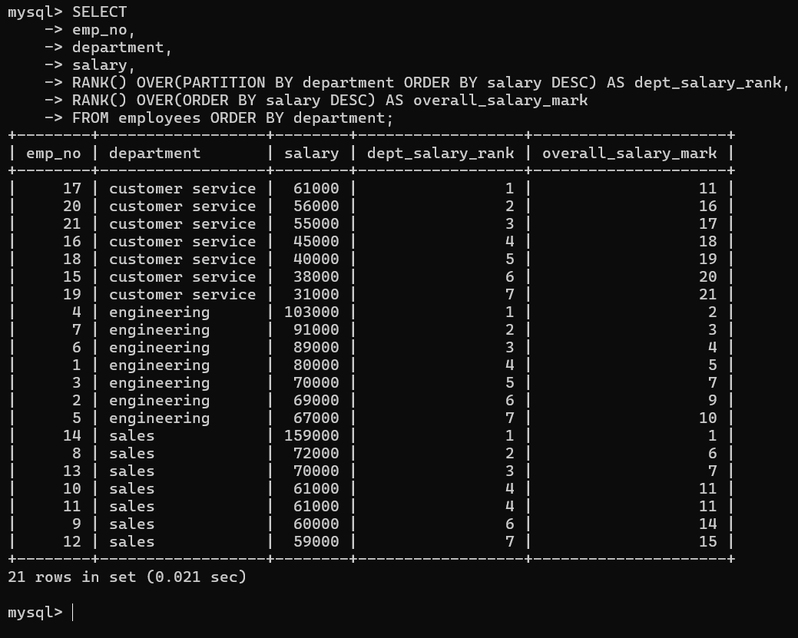

Dept_salary_rank is assigned by each department salary. Overall_salary_rank is assigned to who has the highest salary.

- DENSE_RANK AND ROW_NUMBER()

Row_number is going to label each row within a partition starting with one and going sequentially.

Dense_Rank this function assigns consecutive ranks to peer groups.

CODE:

- SELECT
- emp_no,
- department,
- salary,
- ROW_NUMBER() OVER(PARTITION BY department ORDER BY SALARY DESC) as dept_row_number,
- RANK() OVER(PARTITION BY department ORDER BY SALARY DESC) as dept_salary_rank,
- RANK() OVER(ORDER BY salary DESC) as overall_rank,
- DENSE_RANK() OVER(ORDER BY salary DESC) as overall_dense_rank,
- ROW_NUMBER() OVER(ORDER BY salary DESC) as overall_num
- FROM employees ORDER BY overall_rank;

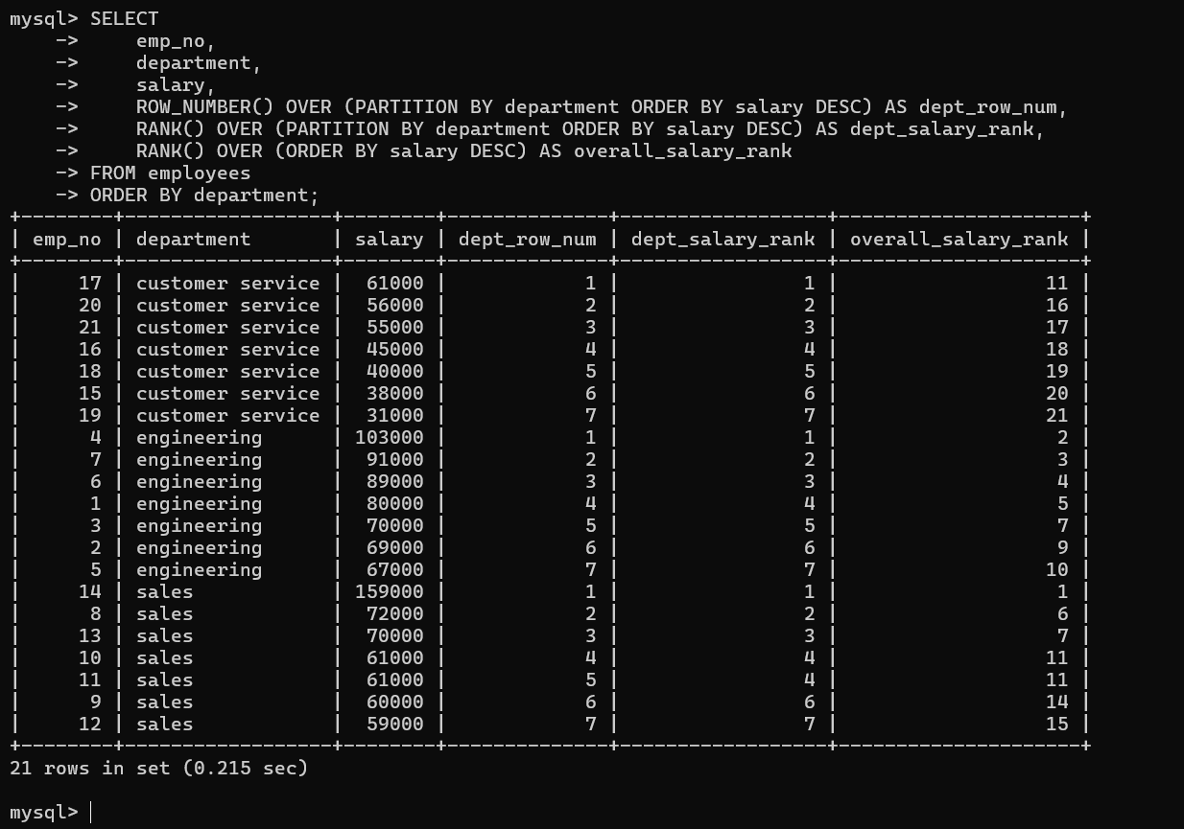

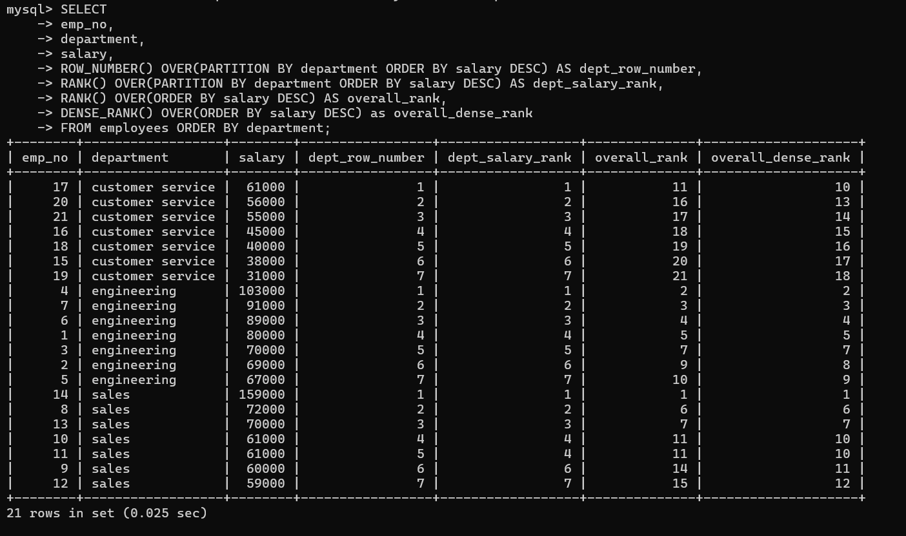
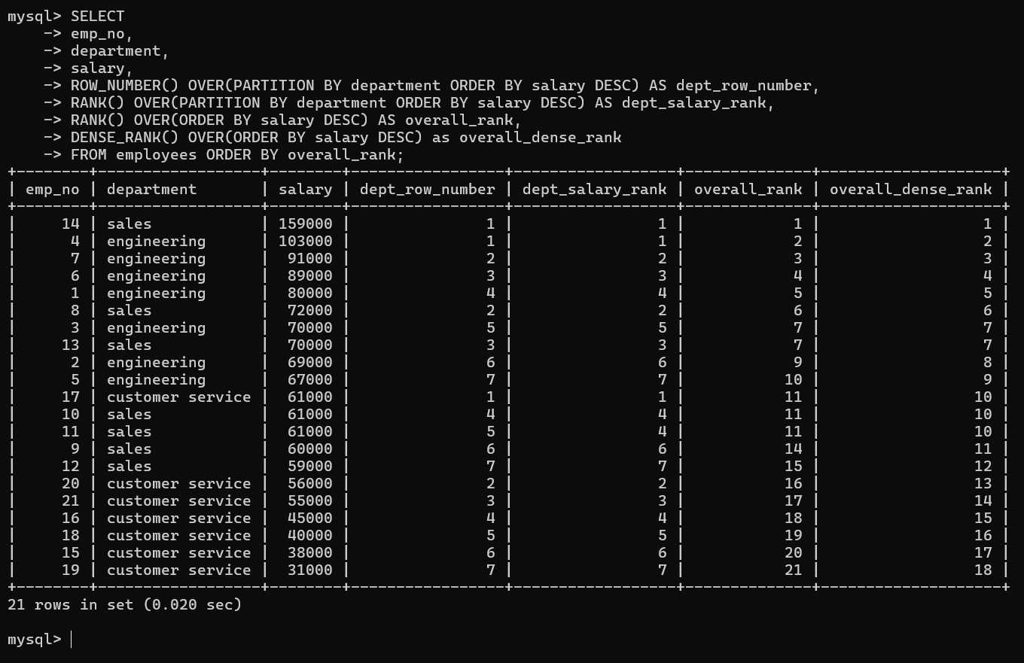

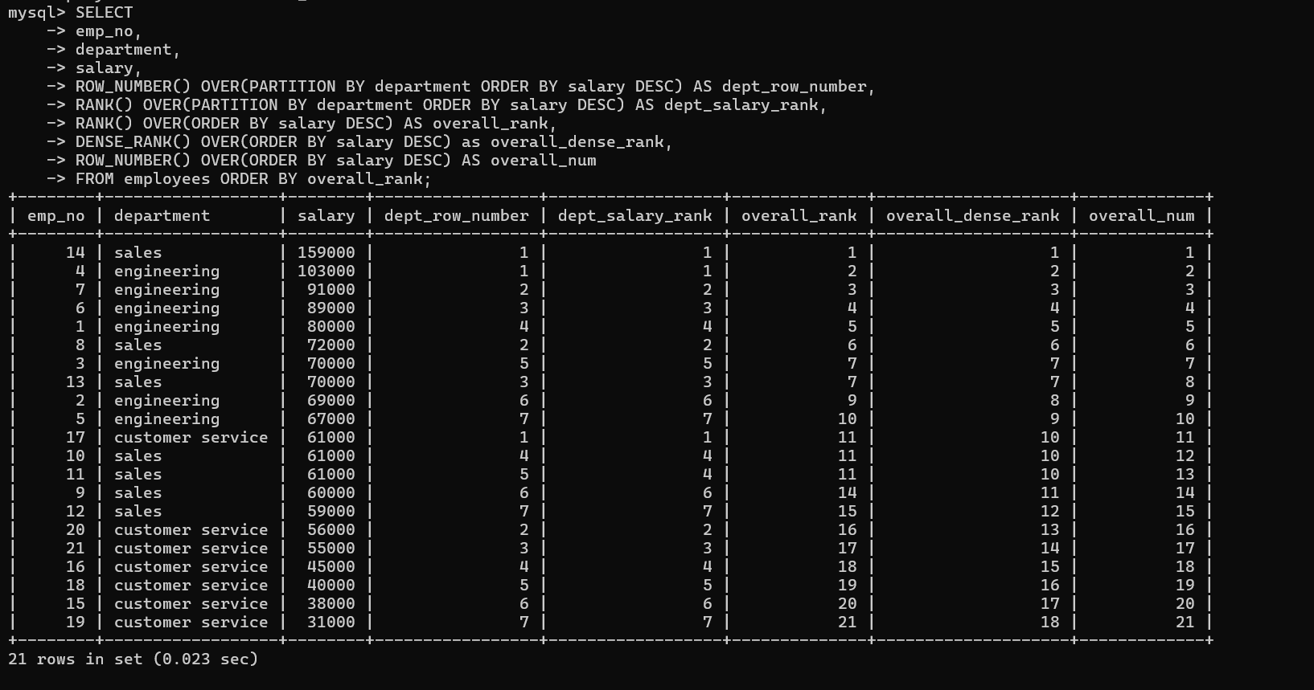

- NITLE

Divides a partition into N groups(buckets), assigns each row in the partition its bucket number and returns the bucket number of the current row.

CODE:

- SELECT
- emp_no,
- department,
- salary,
- NTILE(4) OVER(PARTITION BY department ORDER BY salary DESC) AS dept_salary_quartile,
- NTILE(4) OVER(ORDER BY salary DESC) AS salary_quartile
- FROM employees;

N must be a literal positive integer. Bucket number return values range from 1 to N.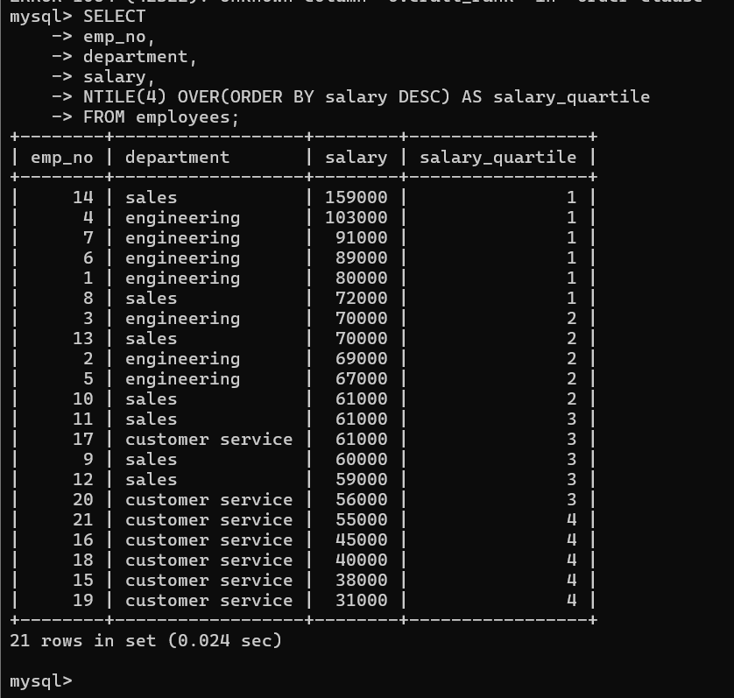

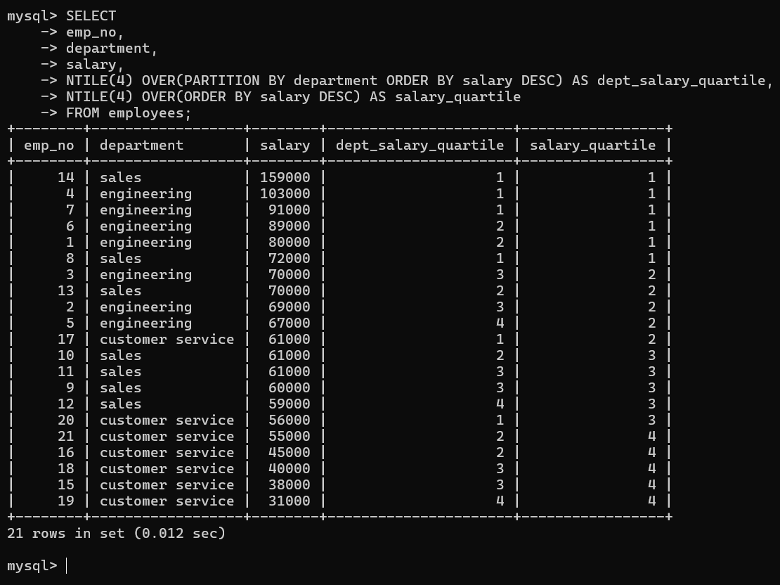

dept_salary_quartile divides employees into four salary groups within each department, ranking them from highest to lowest pay relative to their department peers.

1st 4
Next 4
Next 4
last 4

- FIRST VALUE

Returns the value of expr from the first row of the window frame.
- SELECT
- emp_no,
- department,
- salary,
- FIRST_VALUE(emp_no) OVER(PARTITION BY department ORDER BY salary DESC) as highest_paid_dept,
- FIRST_VALUE(emp_no) OVER(ORDER BY salary DESC) as highest_paid_overall
- FROM employees;

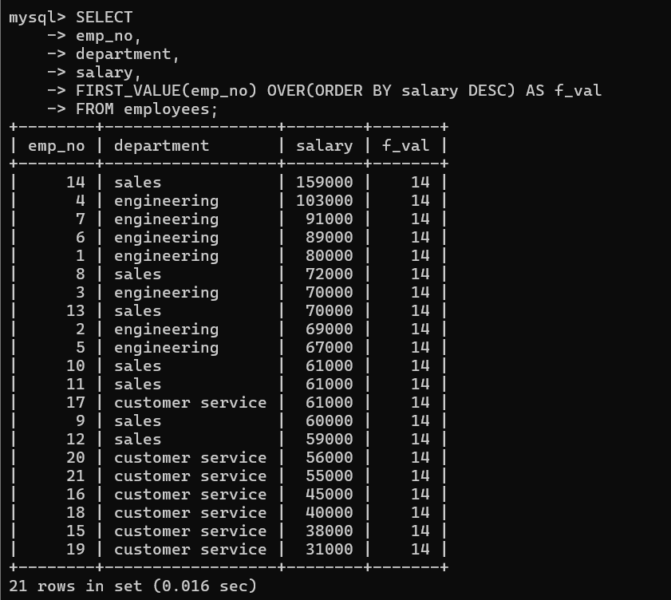

It shows the highest salary emp-no that is the f_val row has value 14.

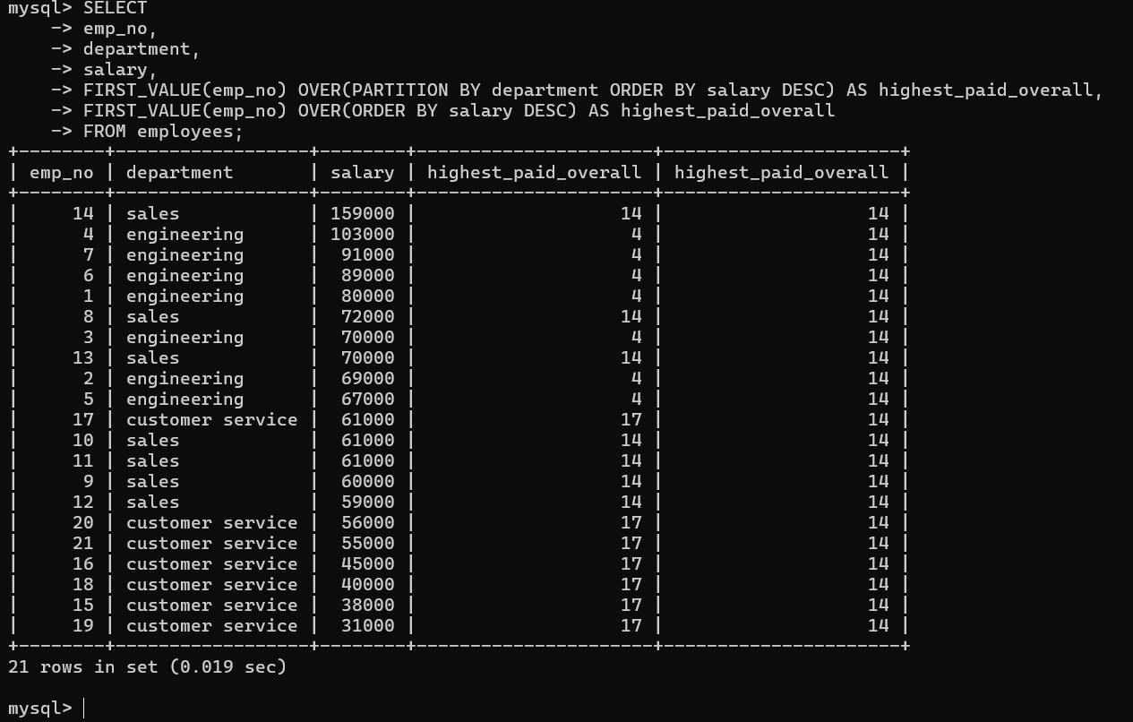

Sales dept high salary is 159000 that emp no is 14 so highest_paid_overall column has value 14 that refer to the sales dept value. Engineering dept highest salary is 103000 that emp no is 4.
Customer service dept high salary is 61000 that emp no is 17.

- LEAD AND LAG

Used to make comparisons to find a difference between one row and the proceeding row or the next row.

Returns the value of expr from the row that lags(precedes) the current row by N rows within its partition.

CODE

- SELECT
- emp_no,
- department,
- salary,
- salary - LAG(salary) OVER(ORDER BY salary DESC) as salary_diff
- FROM employees;

- SELECT
- emp_no,
- department,
- salary,
- salary - LAG(salary) OVER(PARTITION BY department ORDER BY salary DESC) as dept_salary_diff
- FROM employees;

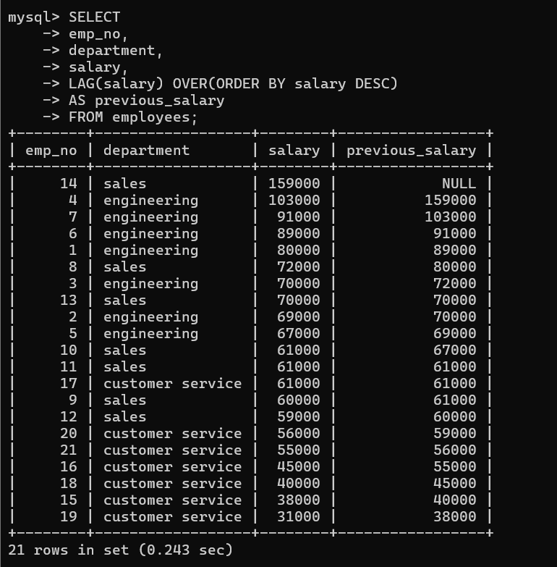

|-> that outcome is PREVIOUS SALARY. USING =>(LAG)

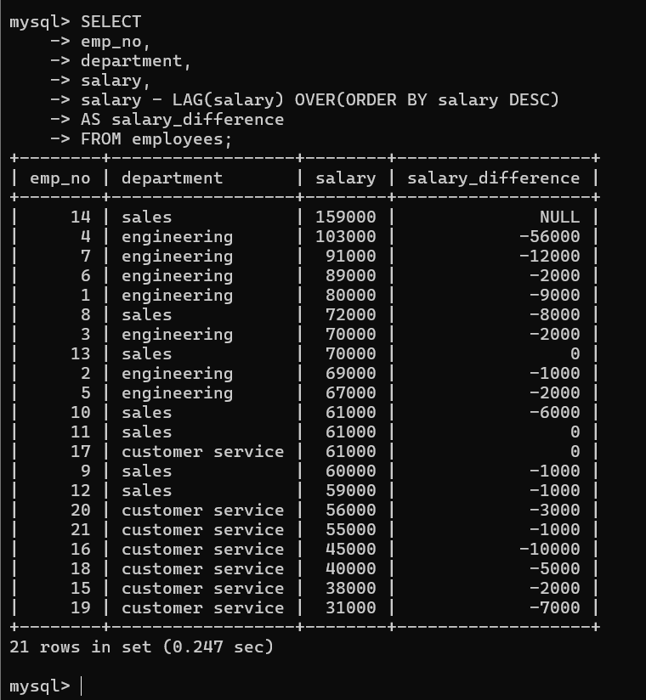

|-> that outcome is subtracted from PREVIOUS SALARY. USING =>(LAG)

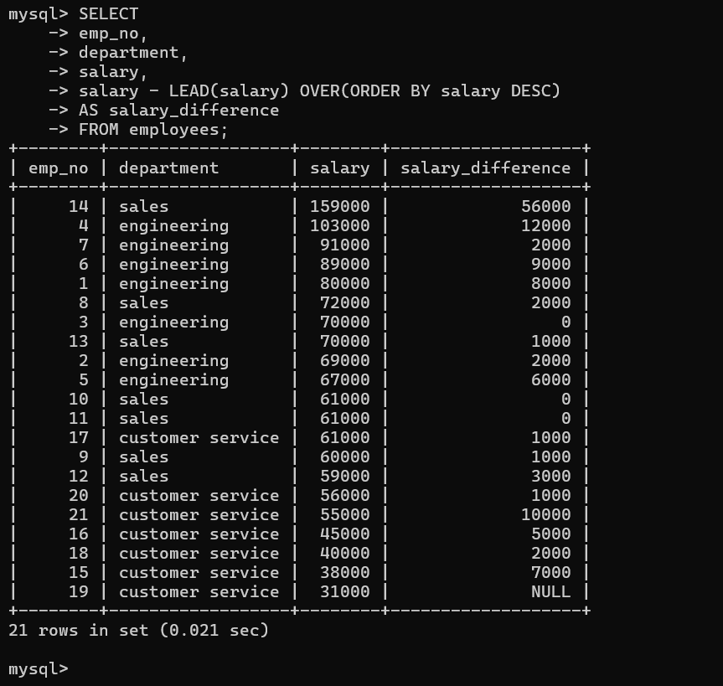

|-> the outcome is Minus the next row salary => 159000-103000 = 56000 and so on.

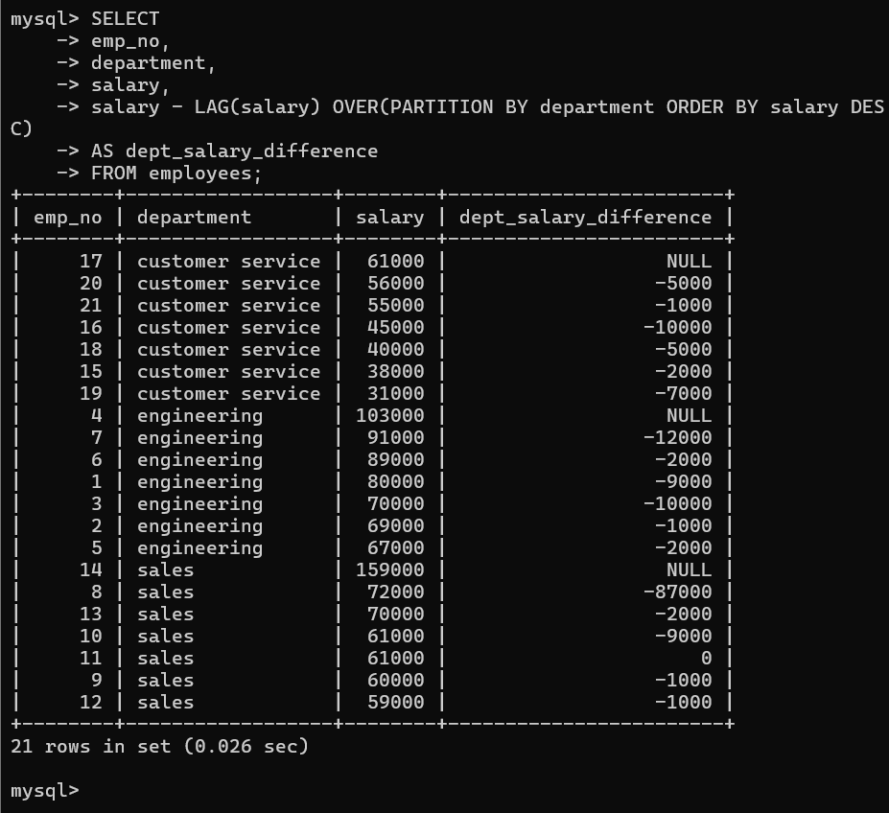

\-> the outcome is each department salary difference 61000-56000 = 5000 and so on.
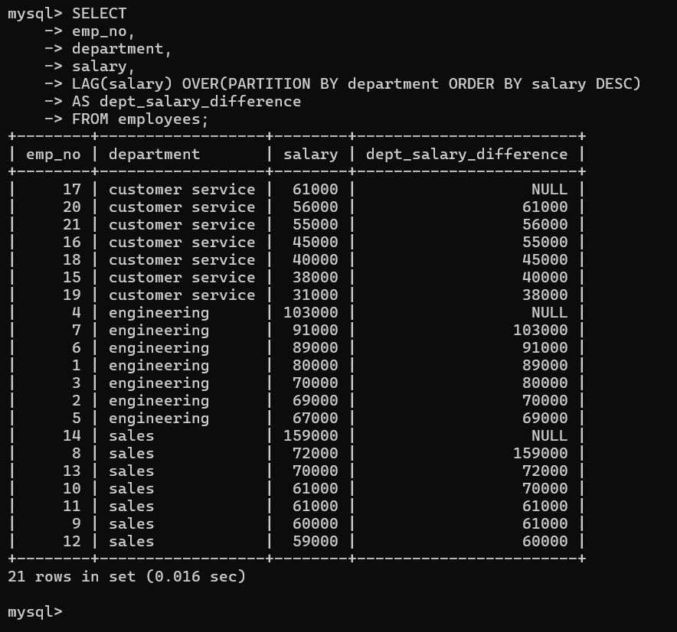
Previous salary.

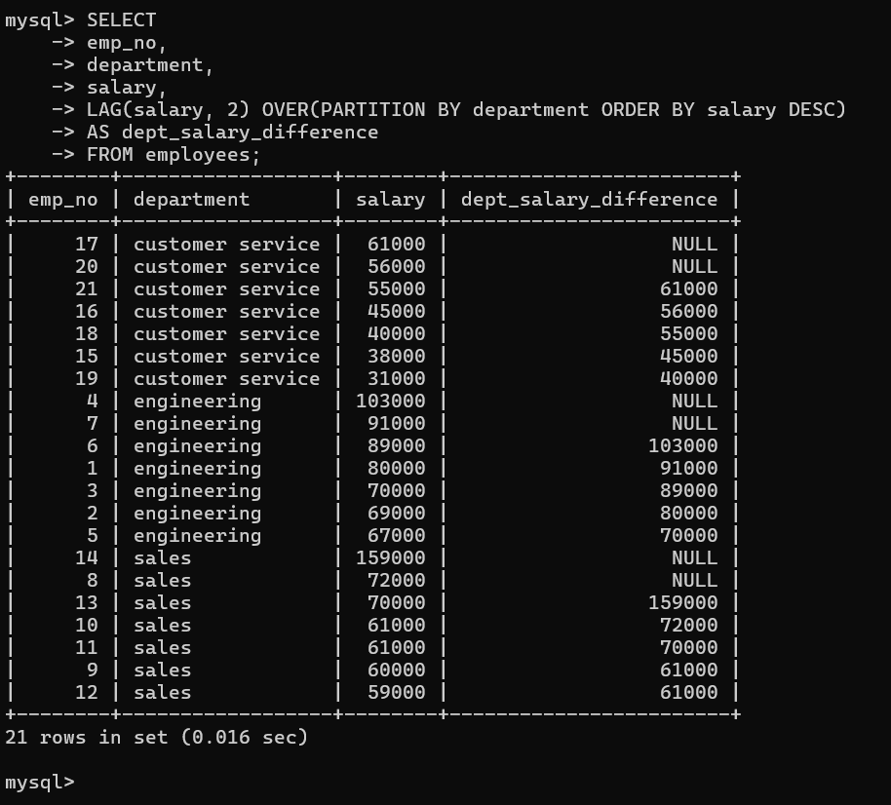

Two steps previous.

